 | IQVIATM Work Instruction  Global Regulatory Affairs - Conducting and Documenting  Communications with Regulatory Authorities
Document Number and Revision:
CS_WI_RA010 Revision 7
Document Owner:  Anja De Pauw | Author(s):  Maggie Rahman

- PURPOSE
To describe the process for conducting and documenting all communication with global Regulatory Authorities.

- SCOPE

  - This work instruction applies to all Global Regulatory Affairs (GRA) staff.

  - This work instruction excludes Regulatory Authority inspections (refer to CS_OP_QA004, Coordinating Regulatory Inspections of IQVIA Facilities).

  - This work instruction is not applicable if GRA are required to follow the customer’s Standard Operating Procedure (SOP) associated with this process.

  - This work instruction does not include project e-mail filing and storage (refer to CS_OP_TMF0007, Trial Master File).

  - This work instruction is applicable to projects where GRA has regulatory responsibility to communicate with a Regulatory Authority(s) and/ or is the official agent for the Customer.

Note: Regulatory Authority communications are submissions and regulatory activities with significant project related discussions requiring correspondence and contact with Regulatory Authorities, in the following form:
    - e-mails
    - telephone/ teleconference
    - written communication/ letters
    - fax
    - meeting minutes

All other communications are not included in this work instruction if they duplicate information already held elsewhere or are of short-term value that do not support or contribute to the decision-making process or outcomes of the regulatory project.

- ROLES AND RESPONSIBILITIES
Role | Sections
Regulatory Team Member (RTM) | 6.1, 6.2

- DEFINITIONS
Not Applicable

- MATERIAL AND EQUIPMENT
Not Applicable

- PROCEDURE
Since all contacts with medicinal product/ device/cosmetics regulatory authorities could potentially have an impact on the customer, project and our business, consistency of communication and proper documentation are critical.

  - Receiving or initiating verbal contact with Regulatory Authority

No: | Who: | Step: | When:
6.1.1 | RTM | Either receives an unannounced phone call or request for a teleconference from the Regulatory Authority OR requests a phone call or teleconference with the Regulatory Authority or directly contacts the Regulatory Authority via telephone as requested by the customer. | After project initiation
6.1.2 | RTM | Determines if any other team member/ technical expert/ customer need to be present on the requested teleconference with the Regulatory Authority. | After request for verbal contact
6.1.3 | RTM | Schedules the teleconference with all attendees. If required, provides an agenda or summary of what the teleconference will cover. | After request for verbal contact
6.1.4 | RTM | If required, facilitates a preparatory call for attendees. | One to two days prior to the teleconference with the Regulatory Authority

  - Documenting, distributing and filing of all communications with Regulatory Authority

No: | Who: | Step: | When:
6.2.1 | RTM | Maintains a log of all communication with the Regulatory Authority. This can be done in the form of a regulatory authority communication log (refer to Appendix B). | After receipt of Regulatory Authority communication
6.2.2 | RTM | Records the evidence of verbal communication (telephone or teleconference) with the Regulatory Authority. This can be done in | After verbal communication

No: | Who: | Step: | When:
 |  | the form of a Regulatory Authority verbal communication report (refer to Appendix C) or an e-mail or via meeting minutes. | with the Regulatory Authority has been completed
6.2.3 | RTM | Saves e-mail communication with Regulatory Authorities in the specific project correspondence folder. | After Regulatory Authority e-mail communication has been sent or received
6.2.4 | RTM | Converts hard copy correspondence to an electronic version by scanning and saving the document accordingly.  (refer to CS_WI_RM0284 General and Trial Master File (TMF)- Specific Document Quality – Good Documentation Practices) | After receipt of physical Regulatory Authority communication
6.2.5 | RTM | Sends the documented communication evidence to the customer and the IQVIA project team in a timely manner. The timing should be based on the content of the Regulatory Authority communication and the timing of any response needed by the Regulatory Authority. | After receipt of Regulatory Authority communication
6.2.6 | RTM | Files the documented communication evidence in the appropriate project folder. | After receipt of Regulatory Authority communication

- SUPPORTING DOCUMENTATION

DOCUMENT NUMBER | TITLE
ESOP References
7.1 CS_OP_QA004 | Coordinating Regulatory Inspections of IQVIA Facilities
7.2 CS_OP_TMF0007 | Trial Master File
7.3 CS_WI_RM0284 | General and Trial Master File (TMF)-Specific Document Quality – Good Documentation Practices

- SUPERSEDES

DOCUMENT NUMBER | TITLE | REVISION NUMBER
8.1 CS_WI_RA010 | Global Regulatory Affairs - Conducting and Documenting Communications with Regulatory Authorities | 6

- MODIFICATION FROM PREVIOUS REVISION

CHANGE | SECTION REFERENCE | JUSTIFICATION
- Updated Role name | 3 and 6 | For harmonization across all GRA SOPs.
- Replaced “Sponsor” by “Customer” | Entire document | For harmonization across all GRA SOPs.
- Replaced reference to  CS_WI_RM048 by CS_OP_TMF0007 | 2.4 and 7.0 | DCR

- APPENDICES
  - Appendix A: Workflows
  - Appendix B: Example of Regulatory Authority Communication Log
  - Appendix C: Example of Regulatory Authority Verbal Communication Report

Appendix A: Workflows

- Receiving or Initiating Verbal Contact with Regulatory Authority
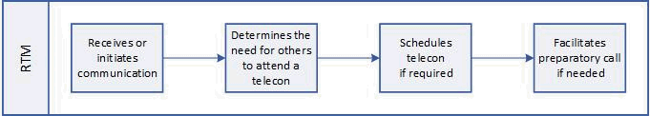

- Documenting, distributing and filing of all Regulatory Authority communications

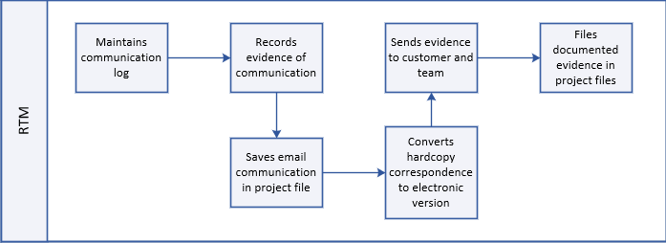

Appendix B: Example of Regulatory Authority Communication Log

Regulatory Authority Communication Log
Regulatory Authority Division:
Regulatory Agent:
Project Manager/ Project Code:
Customer/ Product Name:
Submission No. (e.g., NDA/ MAA/ IND number):

Date of Communication | Type of Communication | Serial Number (if applicable) | Description

Appendix C: Example of Regulatory Authority Verbal Communication Report

Regulatory Authority Verbal Contact Report
Date of Contact: Date of Report:
Project Code:
Regulatory Authority and Regulatory Authority Division:
Type of Contact: Phone Teleconference/ WebEx
Subject/ Reason:
Submission No. (e.g., NDA/ MAA/ IND number)
Product Name:
Marketing Authorization Holder/ Customer:
Regulatory Authority Participants and Telephone number:
IQVIA/ Customer Participants:
Summary:

Outcome/ decisions/ action items:
SIGNATURE:
Name:  Title, Department: | Date:

Page 7 of 7
Copyright © 1999, 2000, 2013, 2015, 2017, 2019, 2021. IQVIA. All rights reserved. The contents of this document are confidential and proprietary to IQVIA Holdings, Inc. and its subsidiaries. Unauthorized use, disclosure or reproduction is strictly prohibited.

UserName: Kemp, Jaco (q608126) Title:
Date: Wednesday, 30 June 2021, 12:11 PM Eastern Time Meaning: Signing this Document Indicates My Approval
================================================

UserName: Corley, Helen (q730385) Title:
Date: Wednesday, 30 June 2021, 12:42 PM Eastern Time Meaning: Signing this Document Indicates My Approval
================================================

UserName: Glizer, Veronica (q735279) Title:
Date: Wednesday, 30 June 2021, 12:53 PM Eastern Time Meaning: Signing this Document Indicates My Approval
================================================

UserName: Balani, Tarun (q830700) Title:
Date: Thursday, 01 July 2021, 12:25 AM Eastern Time Meaning: Signing this Document Indicates My Approval
================================================

UserName: Lobo, Zena (q833472) Title:
Date: Thursday, 01 July 2021, 02:33 AM Eastern Time Meaning: Signing this Document Indicates My Approval
================================================

UserName: Galea, Claudine (q769301) Title:
Date: Thursday, 01 July 2021, 03:46 AM Eastern Time Meaning: Signing this Document Indicates My Approval
================================================

UserName: Rahman, Maggie (q1033930) Title:
Date: Thursday, 08 July 2021, 12:03 PM Eastern Time Meaning: Signing this Document Indicates My Approval
================================================

UserName: Lewicky, Tamara (q730348) Title:
Date: Thursday, 08 July 2021, 12:09 PM Eastern Time Meaning: Signing this Document Indicates My Approval
================================================

